**Test Document for Change Drawback declaration text in custom Invoice**

Testing for XBA001435

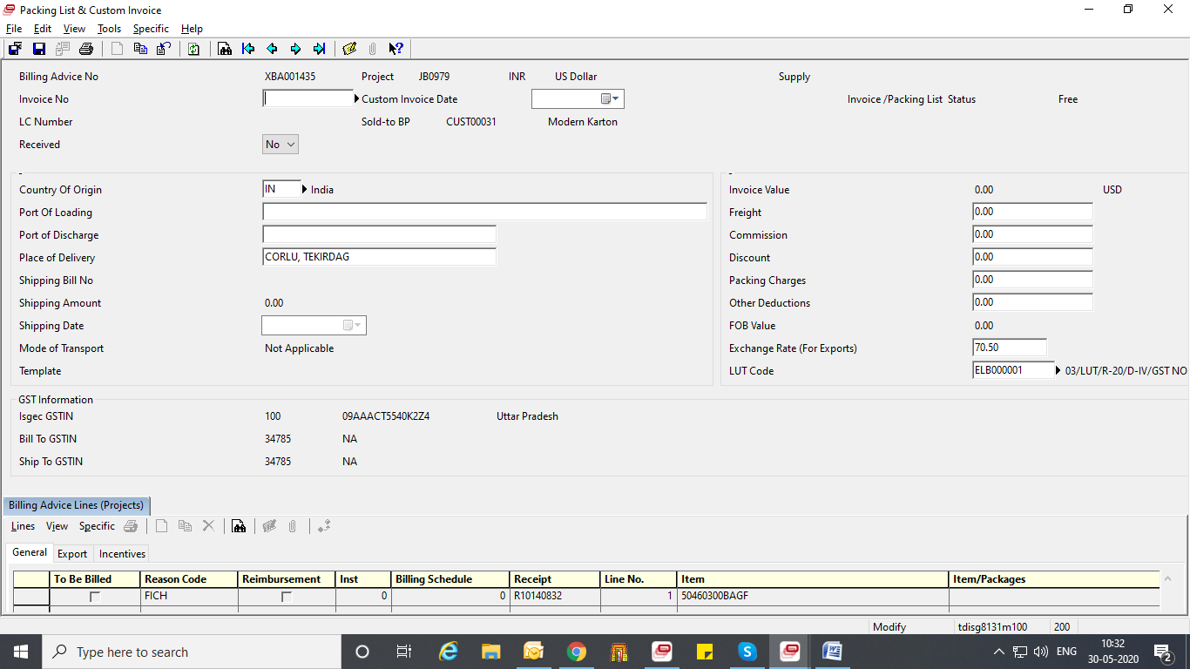

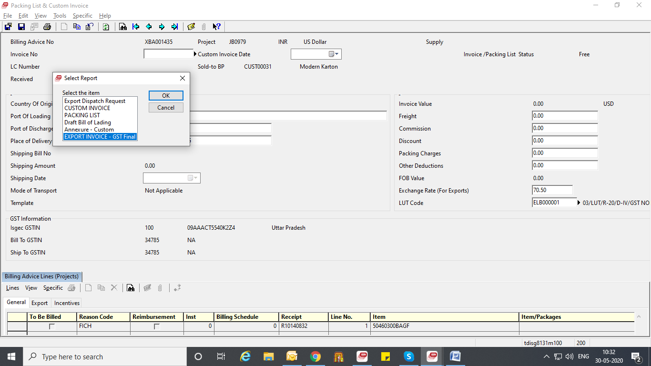

Result:

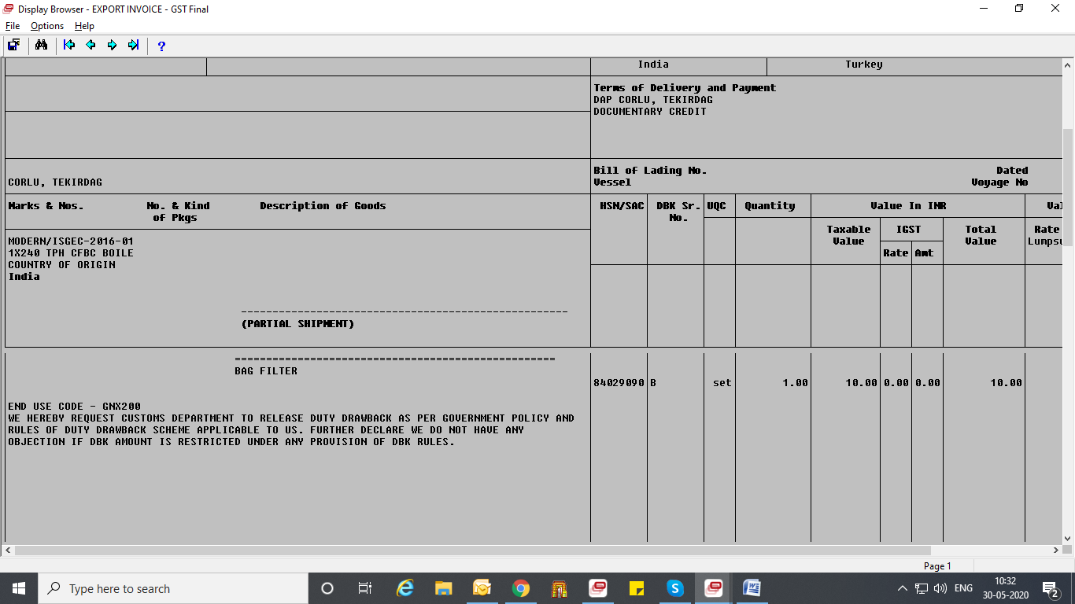

Declaration is replaced.